Turn the message count partial into a universal count partial and call it from anywhere:

Before:

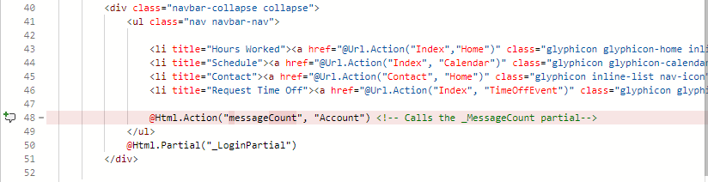

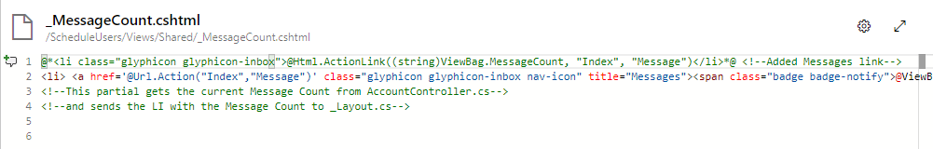

After:

